1. Create the rosgraph for this exercise.
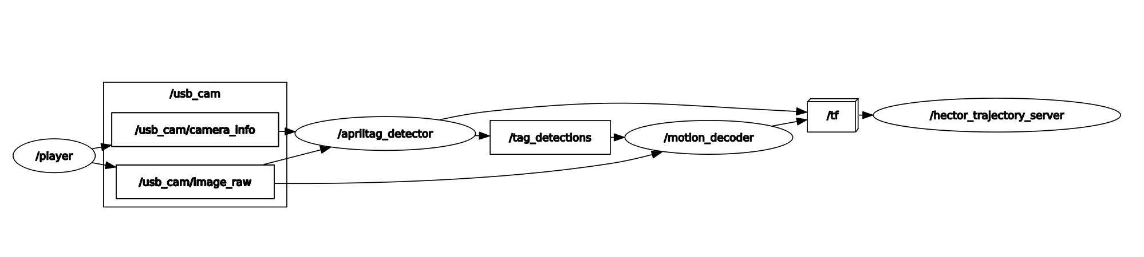

2. Hypothetically, how could you use these packages in your project?
I can use this packages to transform target tomatoes and flowers coordinates to the coordinates relative to the camera. Then transform it to frames in the robot.

3. What did you think of this assignment? Was it helpful to give you a little taste of ROS
packages? Was the difficulty manageable?
It was very helpful. Since I subscribed to ArUco marker and transformed the coordinates for my inverse kinematics algorithm, the topic was familiar to me. However, I learned a lot about launch files, setting the right environment, and setting the paths correctly.

